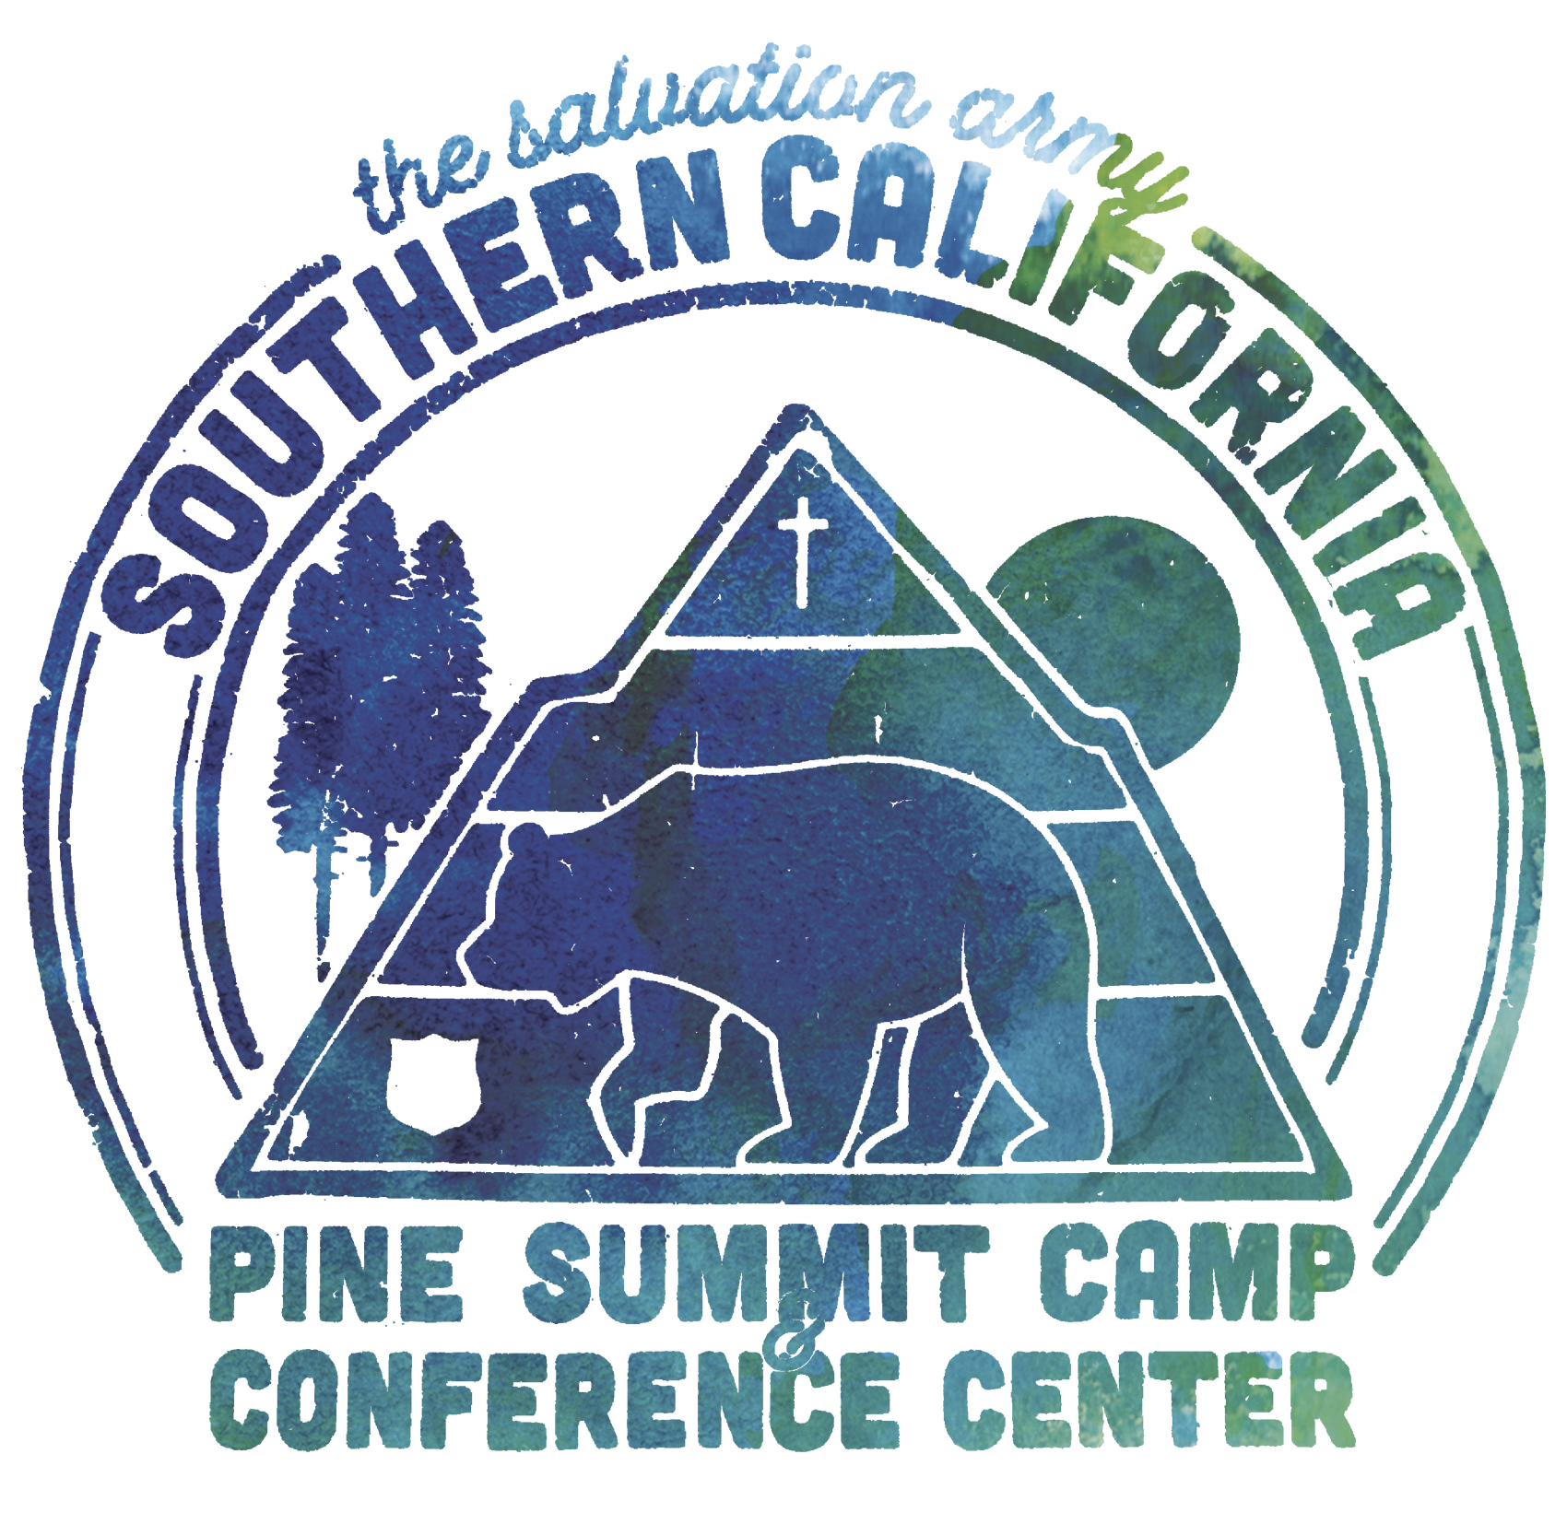

Pine Summit Summer Packing List

**Clothing:**

* Cold-weather clothes; i.e. jackets, pants, coats, etc. (It does get chilly up here at night!)
* Warm-weather clothes; i.e. shorts, t-shirts, tank tops, shorts
* Bathing suit
* Closed-toed shoes
* Hat
* Sunglasses
* Extra clothes if you get wet or dirty

**Personal Items:**

* Bedding, sheets, blankets, pillows (This is provided in Faith, Hope, and Sugarpine Lodges) or sleeping bags.
* A towel (This is provided in Faith, Hope and Sugarpine Lodges)
* Dirty clothes bag/hamper
* Toiletries (Bar soap and/or liquid soap is provided in all lodging)
* Don’t forget your toothbrush and toothpaste!
* Sunscreen (We’re a lot closer to the sun here!)
* Water bottle (It is very dry here and it is important to stay hydrated)
* Your favorite sports equipment
* Your favorite card or board games
* Phone charger
* Money to spend in the snack shop
* Keychain/lanyard to keep track of your lodging keys
* Non perishable snacks (but keep it closed up in your luggage so you don’t attract rodents/ants)
* Any necessary medications